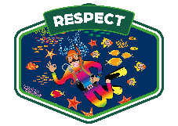
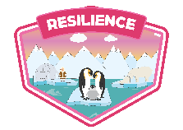
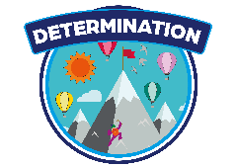
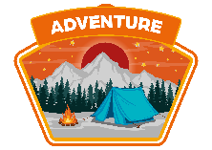
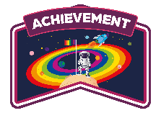
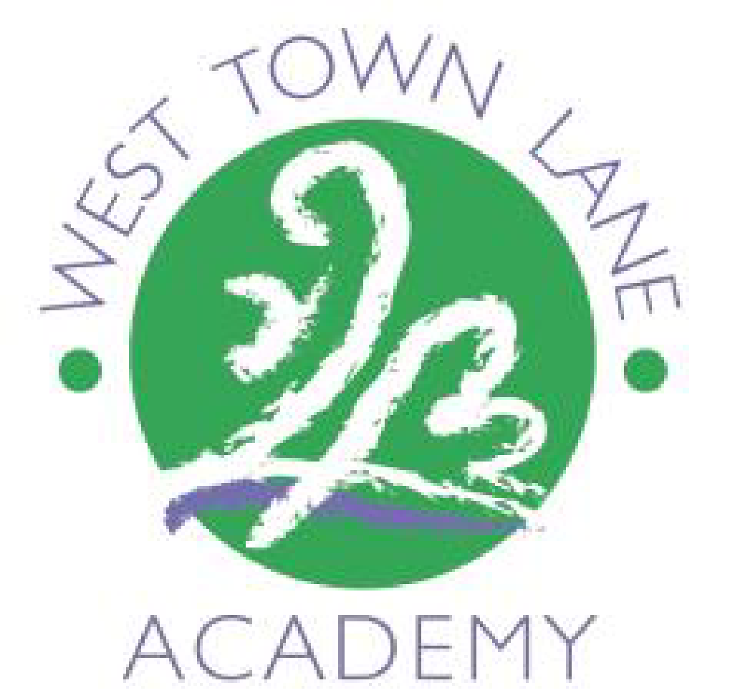
Culture, Diversity and Locality
Whole School Enquiry Overview
 | Term 1 | Term 2 | Term 3 | Term 4 | Term 5 | Term 6
Nursery | Who am I? | Why is winter wonderful? | What makes a good pet? | What happens on the farm? | Who helps me? | What’s in the deep blue sea?
Reception | What makes me marvellous? | What do we celebrate?  RE - What do we celebrate? – learn about various cultures e.g. Diwali | Who’s the meanest story villain? | What’s that twinkling in the sky? | What’s lurking in the garden? | How do things change over time?
Year 1 | What am I?  PSHE: Being me in my world | What makes Brislington & Bristol brilliant?  English – Bristol Bus Boycott  History – What makes Brislington & Bristol unique?  PSHE: Celebrating differences | What did Brunel do for us? | Who are the ground-breaking figures from Bristol’s diverse history?  History – Who is Paul Stephenson, Carmen Beckford and Princess Campbell and what did they do in Bristol? | Where are our capital cities? | How have holidays changed in Weston-super-Mare?
Year 2 | What happened on Pudding Lane?  PSHE: Being me in my world | How has travel changed over time?  PSHE: Celebrating differences | How are all forests the same?  English – Should we keep animals in Zoos? |  | How have people’s rights changed?  History – This enquiry focuses on the lives of Emily Davidson and Rosa Parks. A look into the history of people’s rights across many communities. | What can we do to look after ourselves and our planet?
Year 3 | How did Britain change from the Stone Age to the Iron Age?  PSHE: Being me in my world  PSHE: Celebrating differences |  | How has Ancient Greece shaped our lives? |  | How do UK capital cities compare?  English – Why is the sky so high?
Year 4 | What are the achievements of the Ancient Egyptians?  PSHE: Being me in my world  PSHE: Celebrating differences |  | How do we know the Roman empire was here? |  | Where in the world do they speak Spanish?  English – The Great Panda  Geography - What is life like in Spain?  MFL – Links to Spanish enquiry
Year 5 | Why did the Anglo Saxons, Scots and Vikings raid and invade?  PSHE: Being me in my world  PSHE: Celebrating differences |  | How do China and the UK compare?  English – The Chinese New Year’s celebrations  Geography - China’s Human Rights History. |  | Who were the Mayans?
Year 6 | What happened after the Bristol Blitz?  History – Children learn about Bristol’s Windrush generation.  PSHE: Being me in my world  PSHE: Celebrating differences |  | Could we ever run out of water?  English – How to conserve water  Geography - How does access to water differ depending on where you are in the world? |  | How do animals and plants adapt to suit their environment?

Science – Influential Figures DT – Cooking/food from other cultures Music – Music from other cultures Art - Influential Figures
RE – Religions/cultures from around the world Historical/Geographical link to our locality

