WEST TOWN LANE ACADEMY
Preparing for Nursery

We are so excited to welcome you to our Nursery class at West Town Lane Academy. Your learning journey is off to a fantastic start with us. Here are some ways you can prepare for starting school.

Can you talk about starting nursery? What are you looking forward to?
Can you take a walk past West Town Lane? Can you spot our nursery building?
Can you use the toilet independently? Can you practise good hygiene, e.g. pulling the flush?
Can you wash your hands carefully using soap? Can you dry your hands thoroughly?
Can you put on your own coat? Can you practise getting dressed and undressed independently?
Can you use your knife and fork independently during meal times?

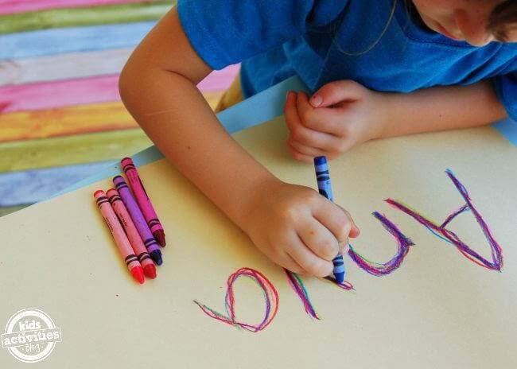
Can you look at a variety of books, holding the book the right way up?
Can you listen well and join in with stories? Can you discuss what happens in the story??
Can you join in with rhymes and songs?
Can you make different marks on paper? Can you make lines or circles?
Can you recognise your name? Can you recognise your belongings?
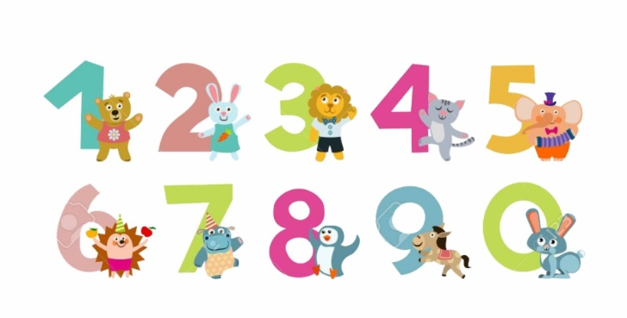
Can you begin to count to 10?
Can you begin to recognise important numbers to you?
Can you recognise shapes in the environment and begin to name simple 2D shapes?
Can you create patterns using colour and shape?

